Unit 3 Assignment

- Do some quick research about New York Courts. What is unique about how the courts are titled as compared to most other state courts in the country?
The New York Supreme Court is the Court of general jurisdiction. The Supreme Court acts as the trial court in New York; however, the highest-ranked Court in the jurisdiction is the New York Court of Appeals. There exists several divisions of courts in New York as can be seen in the picture below. The image taken from nycourts.gov/courts/ proves that there are a wide range of courts in New York compared to Utah. In Utah, the highest-ranking Court is the Utah Supreme Courts, followed by the Utah Court of Appeals. Third, in rank is the Utah District Courts, then the Utah Juvenile Courts followed by the lowest-ranked Utah Justice Courts.

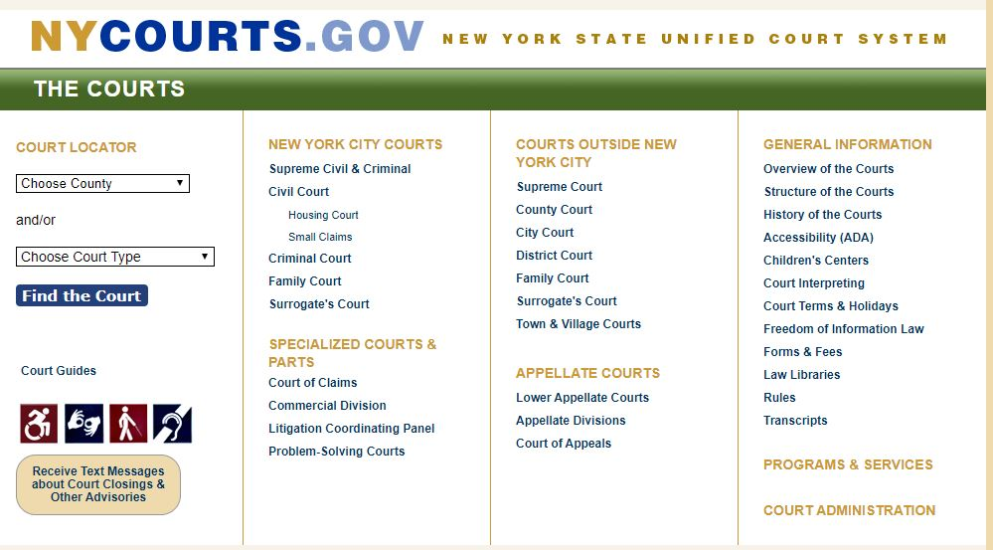
- What types of legal authorities are Basso and Navedo? Are the primary sources? If so, what type of primary? Are they secondary sources? If so, what type of secondary sources?
Since Basso and Navedo are actual cases that have taken place in U.S. courtrooms, they fall under the category of primary sources. Primary sources or authorities are laws that are created by federal or state governments through statutes, codes, the constitution, and case opinions or outcomes. Basso and Navedo fall under the category of case opinions or outcomes, which can be used to determine the outcomes of future cases

- What are the Facts and Procedural History of Basso? What are the Facts and Procedural History of Navedo? This answer should be in a separate paragraph with two headings: "Facts" and "Procedural History."

Basso

Facts: The plaintiff pressed charges and sued the defendant after sustaining an injury as a result of a motorcycle accident while on the defendant's property
Procedural History: In the trial, the Court ruled based on the plaintiff's status as a licensee, trespasser, was hugely determinative of the perceived duty of care that the landowner owed him. The jury ruled the decision rendered for the injured plaintiff, a decision which was affirmed by the Appellate Division.
Navedo

Facts: The plaintiff in the Navedo v. 250 Willis Ave. Supermarket, (290 A.D. 246 [2002]) was a customer who sued the supermarket on the grounds of damages resulting from a slip accident that led to a fall. The incident occurred when the client slid upon stepping on a spilled liquid detergent. The Supreme Court, however, dismissed the complaint, which led to an appeal by the customer.

Procedural History: The plaintiff accused the defendant of negligence, which led to the injury in the Bronx County Supreme Court. The Court ruled against the plaintiff, which resulted in an appeal in the New York Court of Appeal as the plaintiff sought to overturn the initial ruling.

- What is the legal issue in each case? This should be stated in its own section with a heading “Issue(s)”.
Basso
Issues: The Appeal court decided against the initial ruling and remanded for a new trial on the grounds that New York courts would operate under the view that landowners have a responsibility to honor their duty of reasonable care in all situations regardless of the situation of the entrants.
Navedo
Issues: The Bronx Country Supreme Court ruled on the grounds that for liability to be determined, a slip and fall accident must have proof that a dangerous condition was present, and the defendant must be aware of the risk or condition prior to the accident or incident. The Appeal Court, upon relying on witness confession, determined that there was admissible evidence that the store manager was aware of the puddle caused by the detergent spill.
- What is the rule(s) of law that each Court seems to rely on in reaching its decision? This should be stated in its own paragraph: "Rules of Law"

Basso
Rules of Law: The Duty of reasonable care played a huge role in overturning the initial ruling. The grounds of appeal were on the extent of duty care, where the appellant argued that the injuries could have been avoided had the landowner acted more responsibly in his property.
Navedo
Rules of Law: The rule of law is particular that in a slip or fall accident, liability can only be determined when the defendant had prior knowledge of the condition that led to the fall. The Appellate court overturned the first ruling on the grounds of admissible evidence when the plaintiff's neighbor testified.
- Why do you think the Court reached its overall decision? This should be answered in a separate paragraph: "Analysis"

Basso

Analysis: The Court ruled in light of the new perspective that despite owning properties, landowners needed to maintain the required level of reasonable care in their properties to prevent the occurrence of incidences that would otherwise be avoided by proper care.

Navedo

Analysis: Both courts were justified in their respective rulings. The lack of admissible evidence in the form of a witness testifying influenced the first summary judgment ruling. However, the Appeal court rightfully overturned the ruling upon determining that the defendant was well aware of the risk of a fall.

- What was the outcome of each case? This should be stated in its own paragraph, "Conclusion."
Basso
Conclusion: The New York Court of Appeal overturned the initial judgment by the trial court and remanded the case, ordering for a new trial. The ruling in the Basso v. Miller (40 N.Y.2d 233, 352 N.E.2d 868, 386 N.Y.S.2d 564 [1976]) by the Court of Appeal held that a landowner(s) are expected by law to always act as a reasonable person and maintain owned property in view of potential circumstance which includes the probability of injury to visitors, trespassers or anyone else on the property factoring in the burden of risk and the extent of injury sustained.
Navedo
Conclusion: The Court of Appeal overturned the summary judgment delivered by the trial Bronx County Supreme court. The first ruling held that there was a lack of admissive evidence on the awareness of the store manager on the potential risk of a fall due to the presence of a puddle Navedo v. 250 Willis Ave. Supermarket, (290 A.D. 246 [2002]). However, evidence by a witness proved the presence of admissive evidence, which was enough for the Appeal Courts to overturn the initial ruling.
References
Susan Maruca, J.D., MA, Analyzing Facts PowerPoint.
It was accessed On 04/05/2020 at 11:38 AM.

Columbia Law School, Writing Center, (Organizing A Legal Discussion (IRAC, CRAC, ETC.))
Accessed on 04/05/2020 12:18 PM.

Unknown, (N.D.) How to Read Case Law Document.
It was accessed on 04/05/2020 at 1:05 PM.

Susan Maruca, J.D., MA. (N.D.) Part of a U.S. Supreme Court Case.
It was accessed on 04/05/2020 2:25 PM.

Basso v. Miller, 40 N.Y. 2d 233
Accessed on 04/05/2020 3:30 PM.

Navedo v. 250 Willis Ave. Supermarket, 290 A.D. 2s 246
Accessed on 04/05/2020 5:45 PM.

New York Courts – The Courts https://www.nycourts.gov/courts/.
Accessed on 04/05/20 9:13 AM

